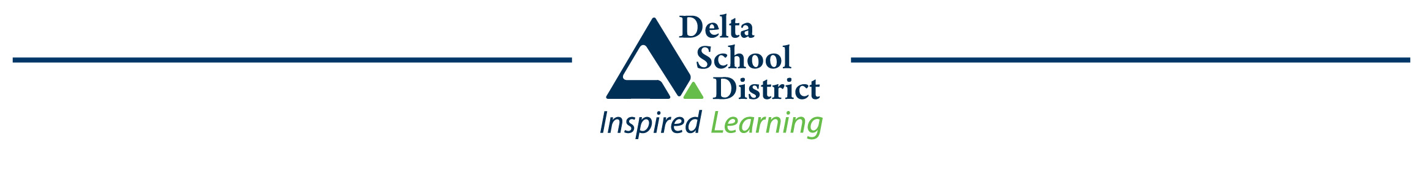

What is Early French Immersion?

The major goal of Delta’s French Immersion program is to provide the opportunity for non-Francophone students to become functionally bilingual in English and French. This is a Kindergarten to Grade 12 program.

You can find more information about Delta’s French Immersion Programs at: www.deltasd.bc.ca/programs/french-immersion/

Early French Immersion Dates and Deadlines

French Immersion Parent Information Nights:
Nov 25th, 2020 at 4pm
Due to the current Pandemic, a pre-recorded Early French Immersion Information presentation will be made available on the Delta School District web site/Programs/French Immersion on Nov 25th, 2020 at 4pm.

Dec 1st at 6:30pm and Dec 2nd at 6:30pm
A Question and Answer period will be held via Zoom on Dec 1st at 6:30pm and Dec 2nd at 6:30pm to replace the in-person Early French Immersion Parent Information Nights that were previously planned. To join the Zoom On-line Question and Answer periods on Dec 1st or 2nd at 6:30pm, please register for the Parent Question and Answer on our website here: https://forms.gle/93EgMGzYZXUpebrP6

Early French Immersion Online Application will be available starting:
January 4, 2021 at 8:00am

Early French Immersion application questions or concerns:
Starting Monday, Jan 4th, 2021 please direct questions or concerns about your application to Gwenaëlle Oger-Black, French Programs Coordinator, gogerblack@deltasd.bc.ca

Early French Immersion Deadline:
Jan 23, 2021 4:00pm

Early French Immersion results:
Feb 9th, 2020, 4:00pm
You should have been contacted with your application results by this date. Please direct questions or concerns about your application to gogerblack@deltasd.bc.ca

Early French Immersion Attendance Areas
Ecole Sunshine Elementary is the attendance area school for students in the catchment areas of Sunshine Hills, Pinewood, Cougar Canyon or Heath.
Ecole Gibson Elementary is the attendance area school for students in the catchment areas of
Gibson, Hellings, McCloskey or Jarvis.
Ecole Devon Gardens Elementary is the attendance area school for students in the catchment areas of
Devon Gardens, Annieville, or Brooke.
Ecole Richardson Elementary is the attendance area school for students in the catchment areas of Richardson, Chalmers, or Gray.
Ecole Ladner Elementary is the attendance area school for students in the catchment areas of
Hawthorne, Holly, Ladner, Port Guichon or Neilson Grove Elementary Schools.
Ecole South Park Elementary is the attendance area school for students in the catchment areas of
Beach Grove, Cliff Drive, English Bluff, Pebble Hill or South Park Elementary Schools.

Grandfathering will be considered for those who already have siblings in the “old” attendance area school.

Application Priorities
If applications exceed space available, six priorities are used to select students:
- Students living in Delta or attending a Delta school within the immersion school’s French program attendance area, and who have siblings in the District’s French Immersion program.
- Students living in Delta or attending a Delta school within the immersion school’s French program attendance area, and who do not have siblings in the District’s French Immersion program.
- Students living in Delta or attending a Delta school outside the immersion school’s French program attendance area, and who have siblings in the District’s French Immersion program.
- Students living in Delta or attending a Delta school outside the immersion school’s French program attendance area, and who do not have siblings in the District’s French Immersion program.
- Students living outside Delta and not attending a Delta school, who have siblings in the District’s French Immersion program.
- Students living outside Delta and not attending a Delta school, who do not have siblings in the District’s French Immersion program.

