BREAKING DOWN THE STIGMA IN SUBSTANCE USE & ADDICTION: A COMMUNITY APPROACH TO SAVING LIVES  The overdose crisis has affected many of us across B.C. Driven by an increasingly toxic drug supply contaminated by Fentanyl and other contaminants, we have lost over 1000 lives since 2016 and it is only increasing. Our very own community has lost loved ones and if we don’t change our current approach, we will only see this number grow.  In this webinar, we’ll present information on how we as a community can help break the stigma attached to substance use an addiction through education, harm reduction, and connecting with our kids. No age is too early to start this important conversation. You will learn current information on the overdose crisis, learn how Delta Police are responding to the crisis and how you can start the preventative conversation with your loved ones.  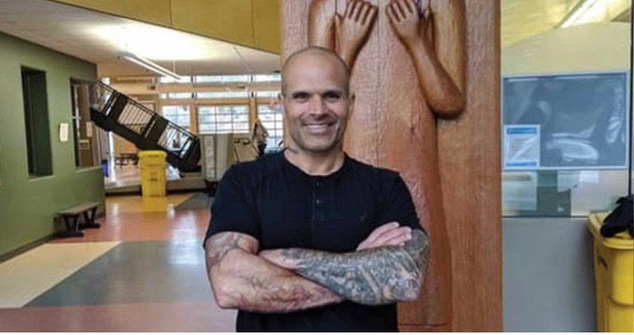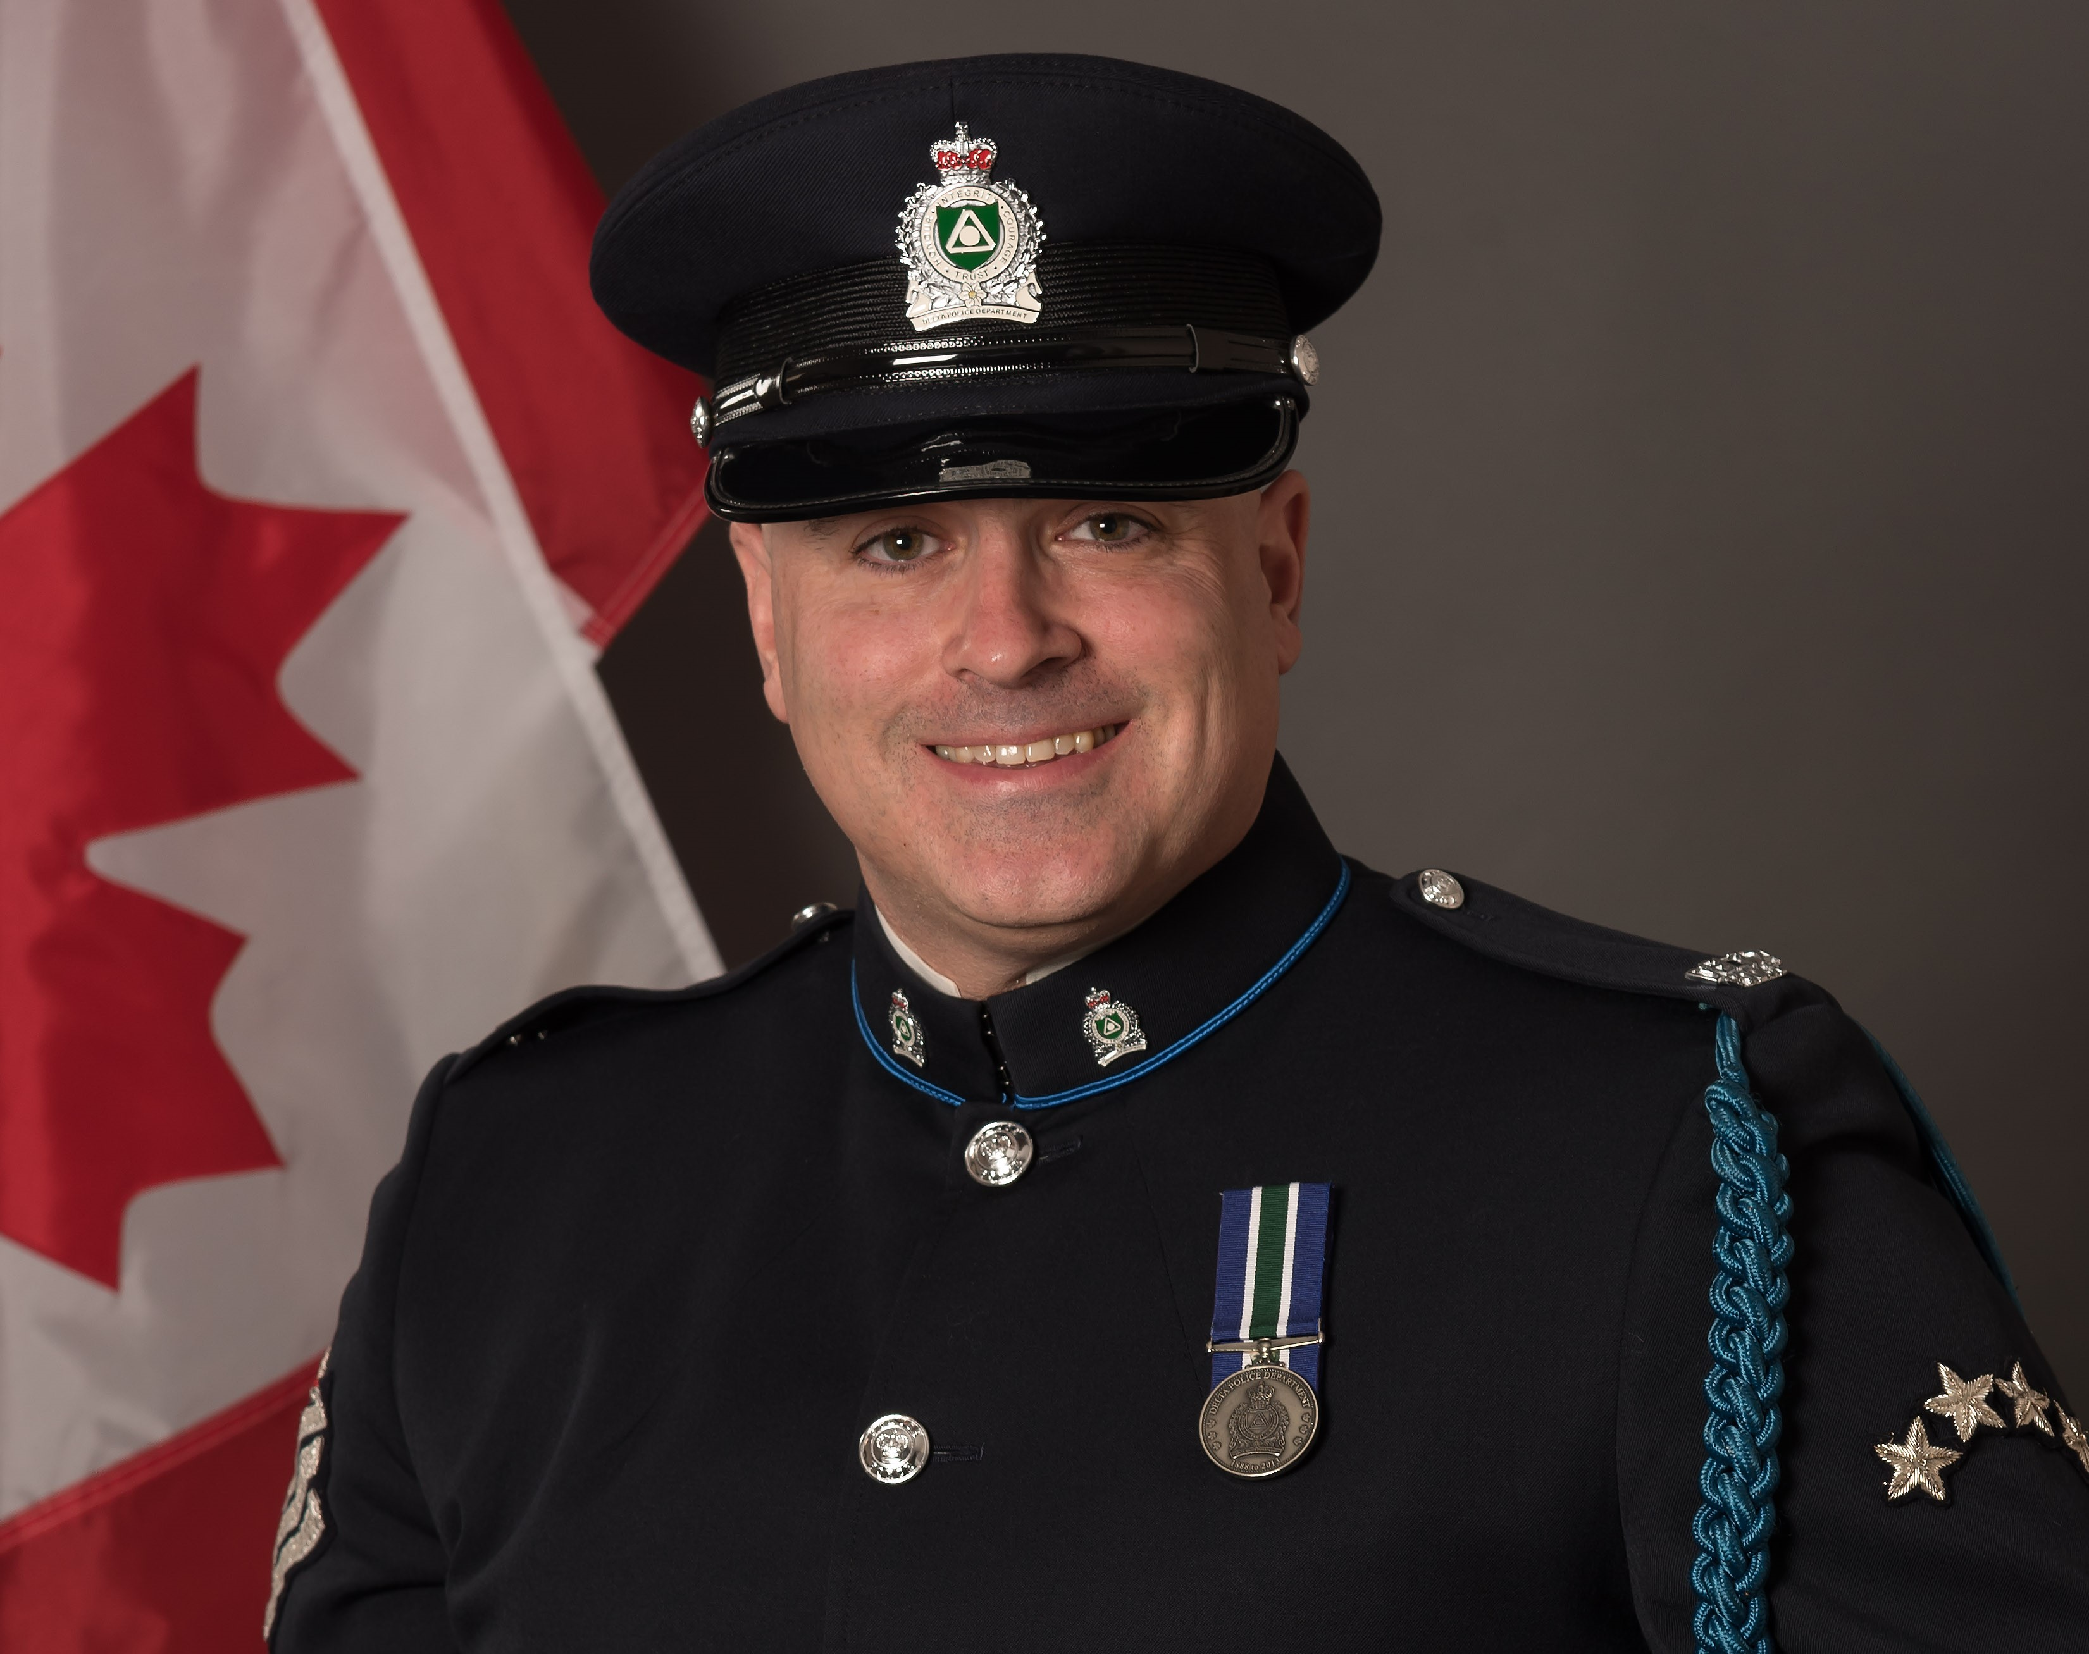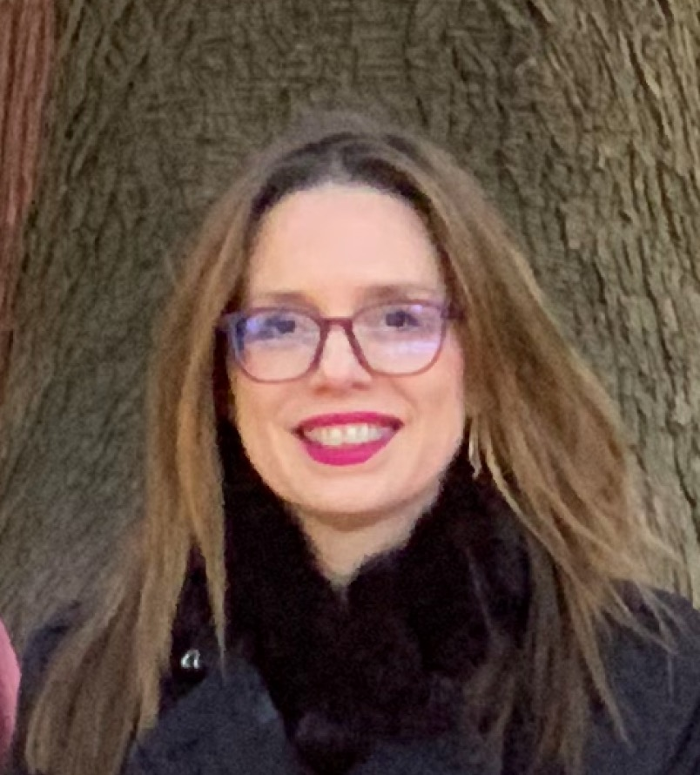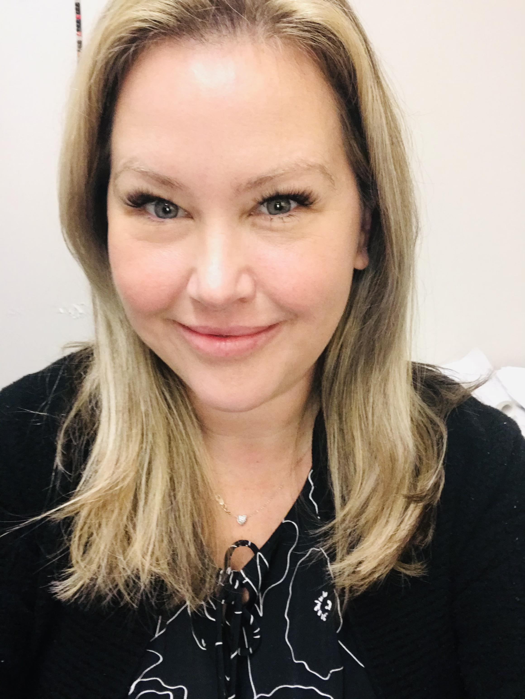  Panel:  Guy Felicella – Harm Reduction Expert & Advocate  Ryan Hall – Inspector – Delta Police Department  Joanna Angelidis, Director Learning Services – Inclusive Learning - Delta School District  Kirsten Hermanson – Manager Prevention & School Wellness –  Delta School District  TUESDAY DECEMBER 15TH AT 6:30 PM VIA ZOOM  REGISTRATION LINK BELOW:  Register in advance for this workshop:  https://ca01web.zoom.us/meeting/register/u5YlcuiqpzovH9Qq_9B_NpKC_2cWywPTMrty  After registering, you will receive a confirmation email containing information about joining the meeting. |  | PRESENTED BY:  a free  education series  FOR the DELTA COMMUNITY  Nov  BN  space is limited  No  Email questions for the panel ahead of time to:  Kirsten Hermanson, Manager – Prevention and School Wellness  khermanson@deltasd.bc.ca

