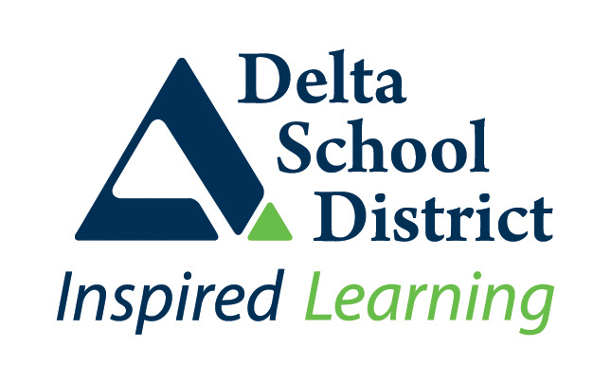 | SD37 – School/Site Specific Communicable Disease Prevention Plan

School Name: Ladner Elementary
Date: Sept. 23, 2021
This plan documents the communicable disease prevention strategies used at your school/site to meet the BC Ministry of Health Provincial COVID 19 – Communicable Disease Guidelines for K-12 Settings and the District’s Communicable Disease Prevention Plan. This plan documents the site specific measures and procedures used at your school/site and can be used as an information tool to inform staff on the prevention measures being employed at your school/site.
Use the Health and Safety Checklist, developed by the BCCDC, as a guide when developing your site specific plan. This plan must also be developed in consultation with your Site Safety Committee.
Public Health Measures
Attendance and Record Keeping

- Staff will continue to sign in upon arrival each day. These documents are filed in the office. Student attendance is completed each morning and afternoon. Daily attendance records are kept through the use of MyEd.
- Visitors and non-regular staff will sign in and sign out using the green sheet located at the front of the office. These documents are filed in the office.
- Class lists and bus lists will be updated as changes occur.
- Staff will be informed of changes and updates through the use of Microsoft Teams and Outlook. In emergency situations, staff phone tree will be used.
- Students will be informed of changes and updates through bulk emails from the office, the school website and Twitter.

Environmental Measures
Ventilation and Air Exchange
- All HVAC systems are operated and maintained as per standards and specifications, and are working properly. Should systems not be working properly, maintenance will be notified through a work order.
- Fans can be used in ventilated spaces, with air moved from high to low. Windows can be open for further air circulation, bearing in mind the thermal comfort of staff and students.
- During times of poor air quality, windows will be closed.
- During excessive heat events, rooms will have cool air flow through the HVAC system. If this cannot be attained, maintenance will be contacted.

Cleaning and Disinfecting
- Frequently touched surfaces are cleaned and disinfected at least 1x a day by our daytime and evening custodians. Surfaces touched by fewer people are cleaned 1x a day.
- Staff have access to disinfectant spray to clean high touch surfaces within the school. Computers and iPads will be disinfected after student use.
- Surfaces that have come in contact with a person’s bodily fluids will be cleaned and disinfected immediately.

Administrative Measures
Gatherings and events
- School gatherings and events are in line with those permitted as per local, regional, Provincial and Federal recommendations and Orders. Room capacities will be enforced and physical distancing will be in place.

Space Arrangement
- In indoor spaces, people have enough room to carry out intended activities without involuntary physical contact and all available space is used.
- For indoor gatherings, people are spread out within the available space and room capacity limits are not exceeded.
- During breaks and other unstructured time in indoor settings, strategies are in place to ensure there is enough space available to prevent involuntary physical contact.

Staff Specific Considerations
- WorkSafe BC guidance for workplace is used to determine measures for staff-only spaces within the school.
- Staff only gatherings held inside will meet public health recommendations. Staff are masked unless eating/drinking, spaced out within the room and room capacities are enforced.

Visitors, including Itinerant Staff, Temporary Teachers on Call, Parents and Others
- Itinerant staff, teachers on call and visitors will be made aware and have access to our communicable disease plan and their responsibility to follow measures at all times.

Curriculum, Programs and Activities
- Students in Music/Band are spaced out within the portable. Masks are worn when singing but can be removed when using an instrument.
- Local field trips occur in line with those permitted per relevant local, regional, Provincial and Federal public health recommendations and orders for local travel.
- Students sanitize or wash their hands before and after gym class.
- Frequently touched surfaces are cleaned and disinfected at least 1x a day by our daytime and evening custodians. Surfaces touched by fewer people are cleaned 1x a day.
- Practices are in place to clean and disinfect frequently touched surfaces when they are dirty.
- General cleaning occurs in line with regular practices.

Bus Transportation
- Practices are in place to encourage bus drivers and passengers to practice hand hygiene before and after trips. Students (Gr.4-7) and drivers must wear a mask while on the bus and stay spaced out. Windows are opened to allow air circulation when the weather allows.
- Grade K-3 students wear masks based on their personal or caregiver’s choice. Masks are encouraged for everyone.

Food Services
- Prepackaged food can be distributed and shared. Food made in an industrial kitchen can be distributed by individuals wearing masks, gloves and tongs.

Community Use of Schools
- Community use of school facilities is aligned with related public health guidance, recommendations and Orders.

Water Fountains
- Water fountains continue to only be used to fill up water bottles. No fountains are in use at this time.

Personal Measures
Daily Health Checks
- Staff and students made aware of the need to continue daily health checks prior to arriving at work/school
- Daily Health checklists have been sent home for families to complete each day with their child prior to sending them to school.

Stay home when sick/what to do when sick
- Signage posted at entrances indicating daily health check must be performed and to not report to work/school if experiencing illness
- Staff and students are regularly reminded to stay home when they are sick

Symptoms develop at school
- When a staff member, student or other person develops symptoms while at school, they are expected to distance from others and go home if/when possible.

Returning to school after illness
- Health care provider notes are not required to confirm the health status of any individual, beyond those required to support medical accommodation as per usual practice.

Hand hygiene and Respiratory Etiquette
- Hand cleaning facilities are available and accessible throughout the school and are well maintained. (e.g., soap and water, hand sanitizer)
- Students and staff are expected and encouraged to wash hands frequently throughout the school day.

Personal Protective Equipment Measures
Masks
- Staff, students (Grade K-7) and visitors wear a mask or face covering within the school building.
- Masks are available at the office upon request.
- The district will provide masks to the school for those who forget one
- Gloves, masks and face shields are available for first aid attendants to use.

School Supportive Environments
Personal Prevention Practices
- Strategies are in place to routinely support students to practice personal prevention measures like hand hygiene and respiratory etiquette.

  - Signage
  - Announcements
  - Modeling/mentoring proactive behaviour

Personal Space
- Strategies are in place ensuring staff/students consider and respect the personal space of others. Personal space is the distance from which a person feels comfortable being next to another person.

Positive and Inclusive Approaches
- Strategies are in place for creating positive and inclusive approaches to personal prevention strategies

