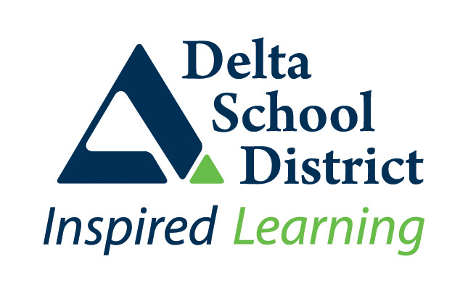 | SD37 – School/Site Specific Communicable Disease Prevention Plan (Addendum as of January 2022)

School Name: Ladner Elementary
Date: January 4, 2022
This plan documents the communicable disease prevention strategies used at your school/site to meet the BC Ministry of Health Provincial COVID 19 – Communicable Disease Guidelines for K-12 Settings and the District’s Communicable Disease Prevention Plan. This plan documents the site specific measures and procedures used at your school/site and can be used as an information tool to inform staff on the prevention measures being employed at your school/site.
Environmental Measures
Learning Space Configuration

-learning spaces are arranged to maximize the space available and to avoid people directly facing one another (where possible)

Ventilation and Air Exchange
- All HVAC systems are operated and maintained as per standards and specifications, and are working properly. Should systems not be working properly, maintenance will be notified through a work order.
- Schools with recycled/recirculated air systems have upgraded their current filters to MERV 13 where possible or have identified mitigation efforts.
- If using portable fans or air conditioning units, ensure they are set up to move air downward and not blowing directly from one person’s breathing zone to other occupants of a room. Avoid horizontal cross breezes.
- Risk mitigation strategies are identified for excessive heat events or times of poor air quality.

Increased Cleaning and Disinfecting
- Frequently touched surfaces (those touched by larger numbers of people) are cleaned and disinfected at least 1x/day. Surfaces touched by fewer people are cleaned 1x/day.
- Practices are in place to clean and disinfect frequently touched surfaces when they are dirty.
- Other general cleaning occurs in line with regular practices.
- Practices are in place to clean and disinfect and surfaces a person’s bodily fluids have contacted after they have displayed symptoms of illness.

Administrative Measures
Gatherings and events
- School gatherings and events (assemblies, etc) are held virtually, whenever possible.
- If gatherings and events must be in person, the number of people in attendance is minimized as much as possible, does not exceed 50% operating capacity, and spectators are not present.

Space Arrangement
- In indoor spaces, people have enough room to carry out intended activities without involuntary physical contact.
- Spaces are configured to maximize space between people.

Staff-Only Gatherings
- Staff gatherings (staff meetings, in-service and professional development activities, etc) occur virtually.

Itinerant Staff, Temporary Teachers on Call and Other Visitors
- Process in place to ensure itinerant staff, teachers on call and visitors are aware of the school’s health and safety measures and their responsibility to follow them at all times.

Extracurricular Activities
- Sports tournaments are paused.

Hand Hygiene
- Hand cleaning facilities are available and accessible throughout the school and are well maintained.

Bus Transportation
- Frequently touched surfaces are cleaned and disinfected at least 1x/day. Surfaces touched by fewer people are cleaned 1x/day.
- Practices are in place to clean and disinfect frequently touched surfaces when they are dirty.
- Other general cleaning occurs in line with regular practices.
- Everyone on the bus (without exemptions), wear masks in accordance with the PHO Order on Face Coverings.
- Practices are in place to encourage bus drivers and passengers to practice hand hygiene before and after trips.
- Passengers are spread out if empty seats are available.
- Windows are opened when the weather allows.

Personal Measures
Daily Health Checks
- Parents and students are reminded of their responsibilities to complete a Daily Health Check and are provided resources on hot to complete one (e.g. the K-12 Health Check App).
- A process is in place to track and ensure that staff and visitors complete their Daily Health Check prior to arriving at school

Stay home when sick
- Staff and students are regularly reminded to stay home when they are sick

Symptoms develop at school
- Practices are in place to appropriately respond when a staff member, student, or other person develops symptoms of illness while at school.

Personal Protective Equipment
Masks
- Everyone at school (without exemptions), wear masks in accordance with the PHO Order on Face Coverings.
- Masks are available for those who have forgotten theirs.
- Schools work with those with mask exemptions to explore potential strategies to reinforce and enhance other safety measures, as described in the COVID-19 Planning Resource: Mask Exemptions.

School Supportive Environments
Personal Prevention Practices
- Strategies are in place to routinely support students to practice personal prevention measures like wearing a mask and hand hygiene (signs, included in morning announcements, etc)

Personal Space
- Strategies are in place ensuring staff/students consider and respect the personal space of others. Personal space is the distance from which a person feels comfortable being next to another person.

Positive and Inclusive Approaches
- Positive and inclusive approaches aligned with existing school/sector practices to address behaviour/personal practices are used.

